The still warm sugar palm juice is poured in and yeast is added. The yeast eats the sugar and excretes ethanol.

The livestock eat the algae. They provide food for local communities.
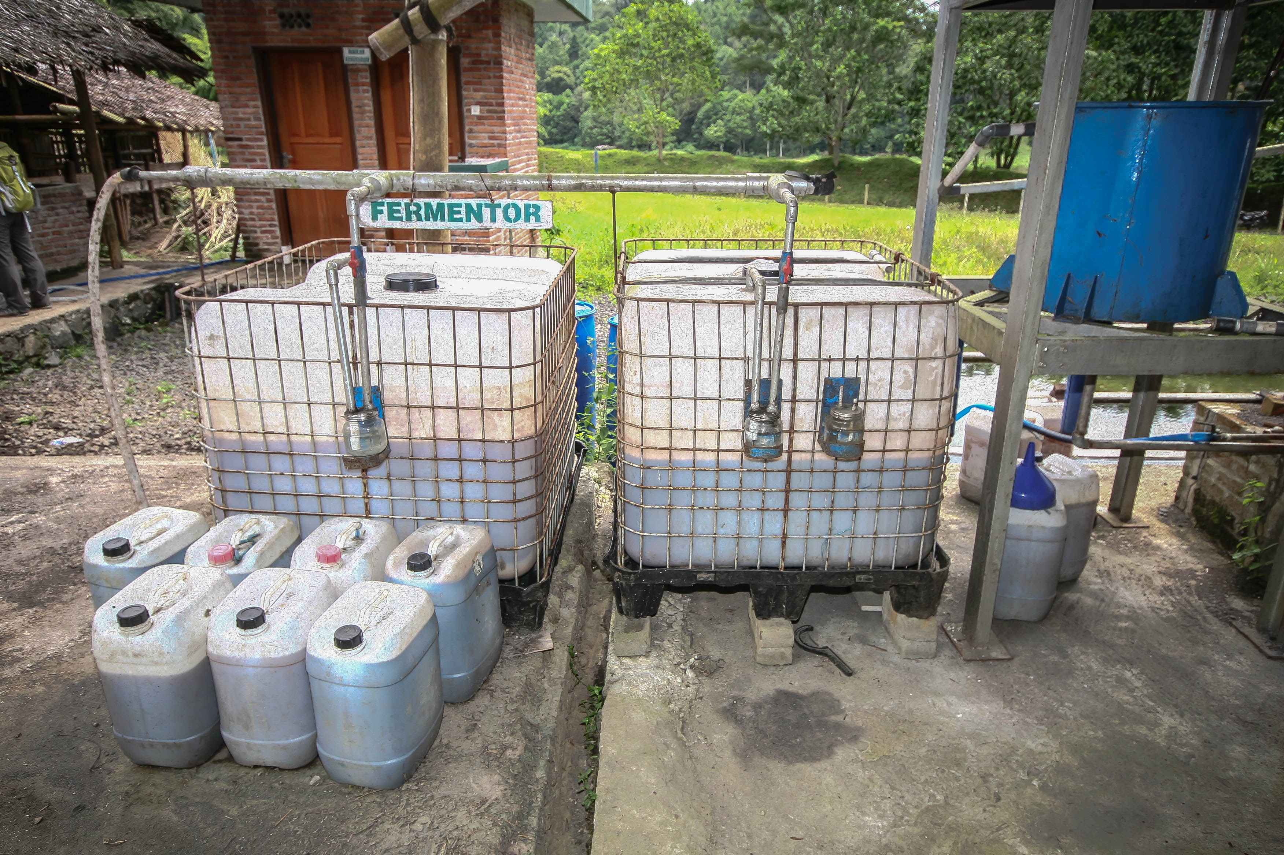
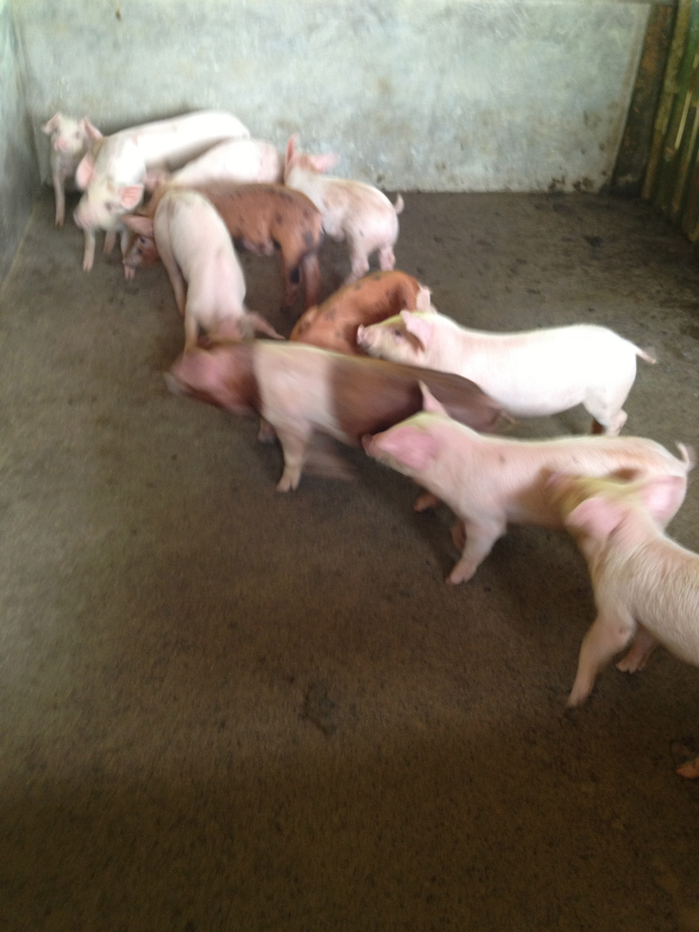

PIGS

The ethanol is extracted from the fermented juice by distilling. The ethanol can then be used for fueling motorbikes, powering light and providing clean cooking fuel for local communities.

The bi product of fermentation is Co2. This is captured in a balloon and fed into an algae pond. The algae is then harvested and fed to animals.
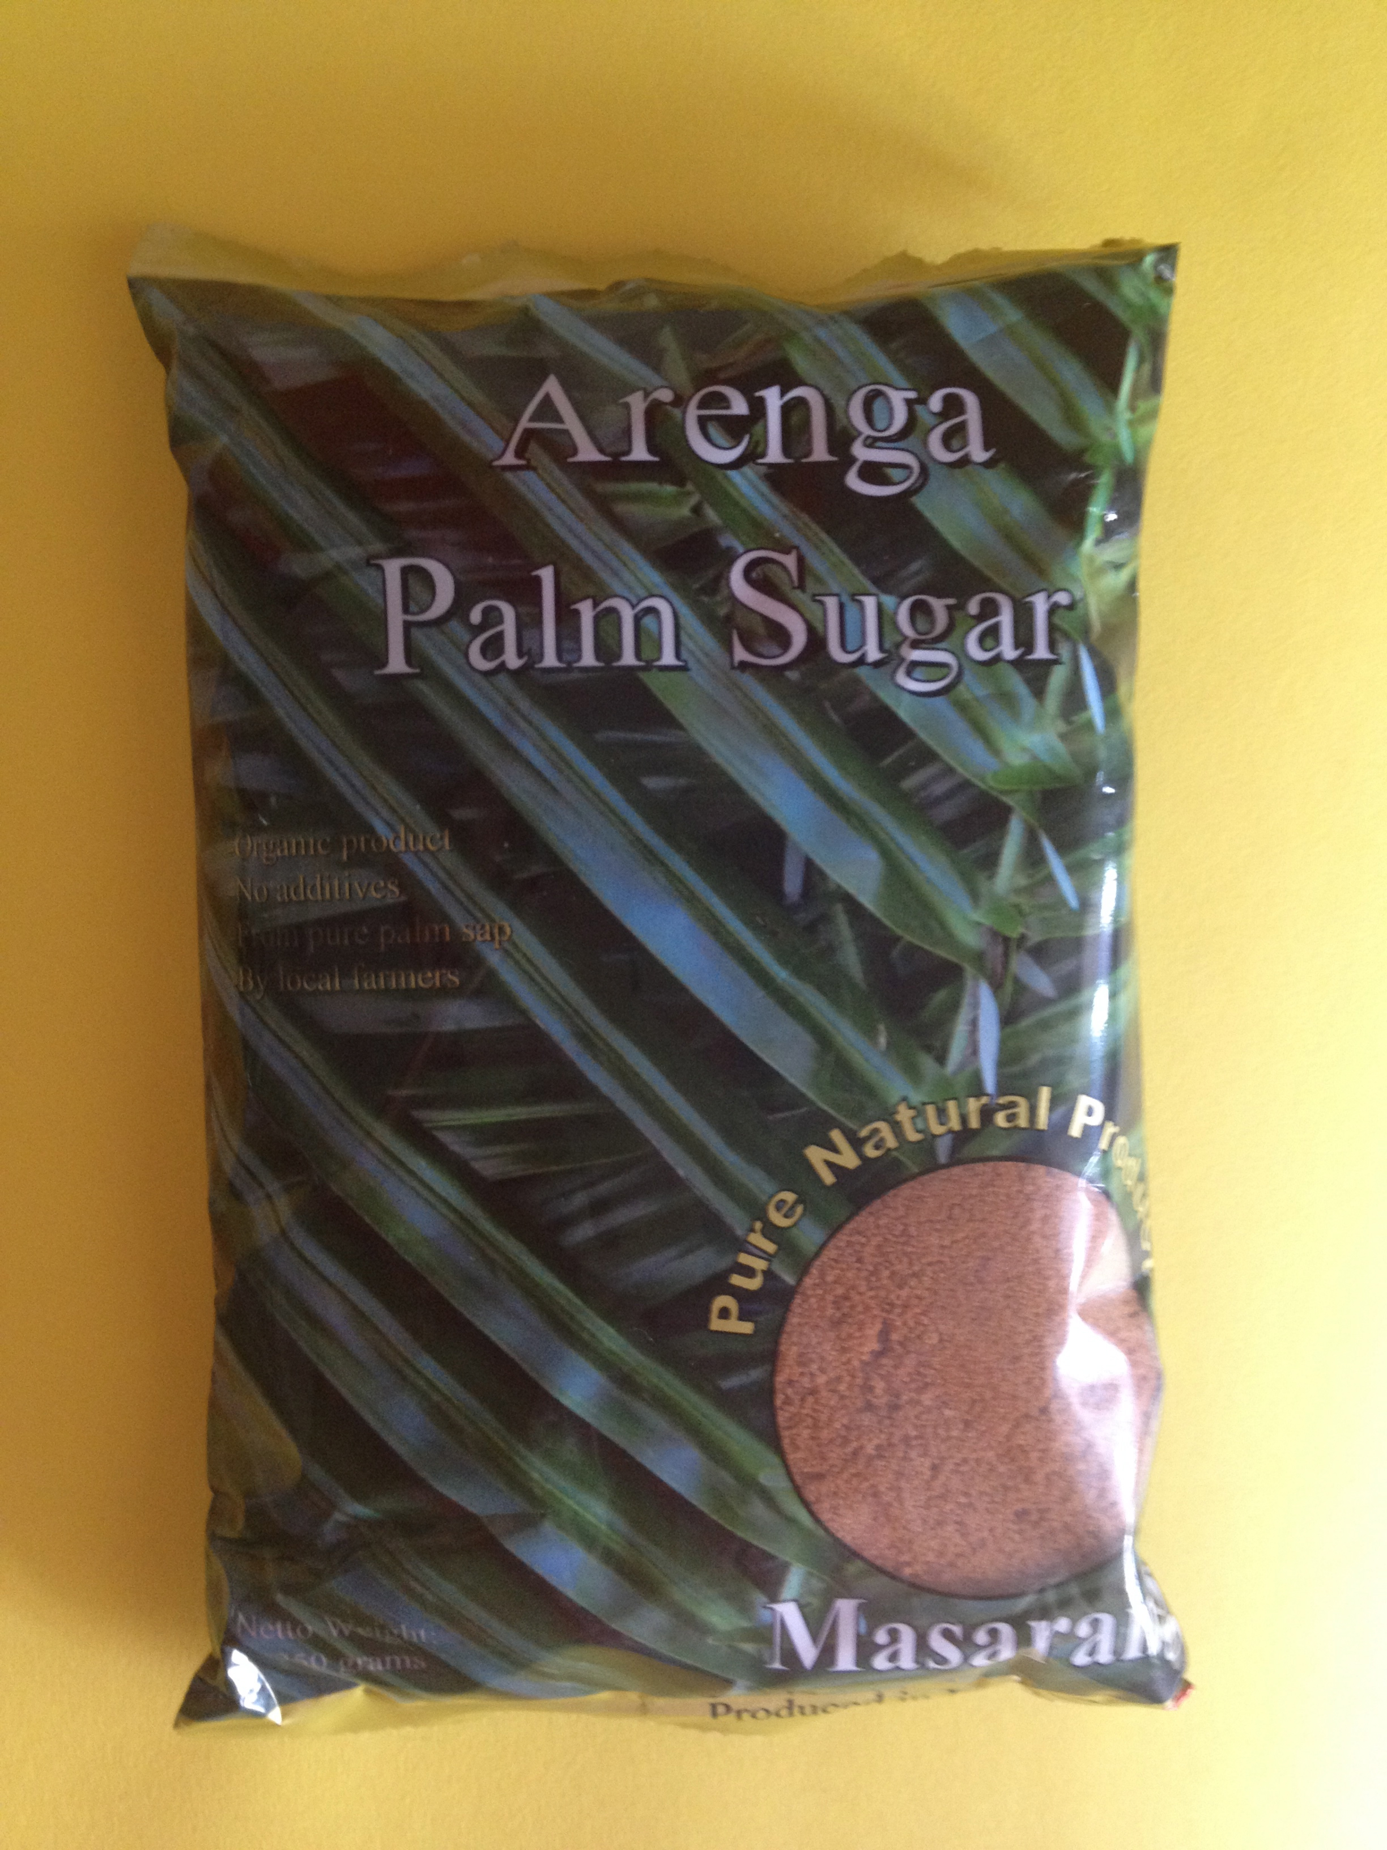
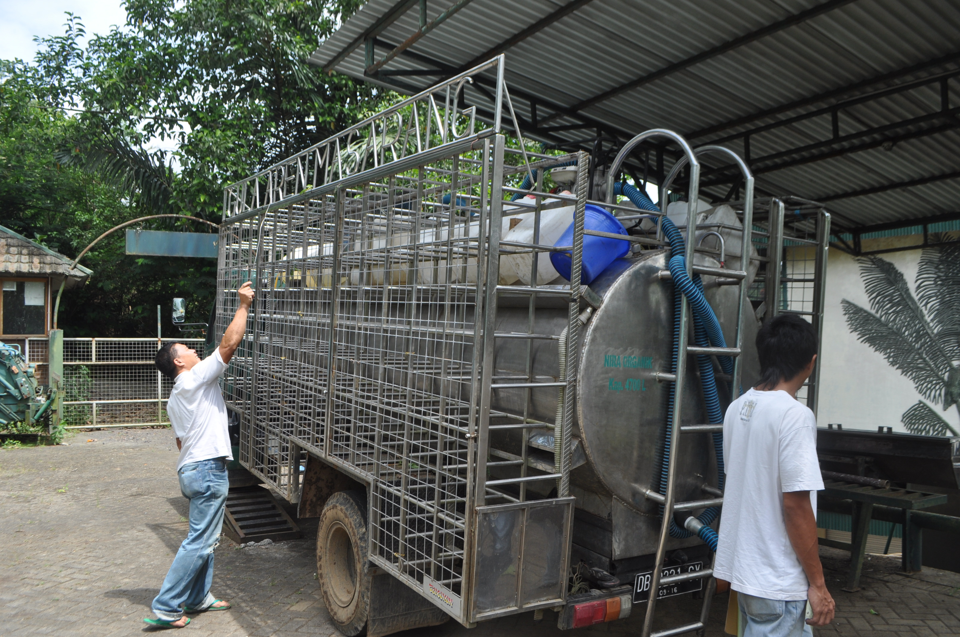

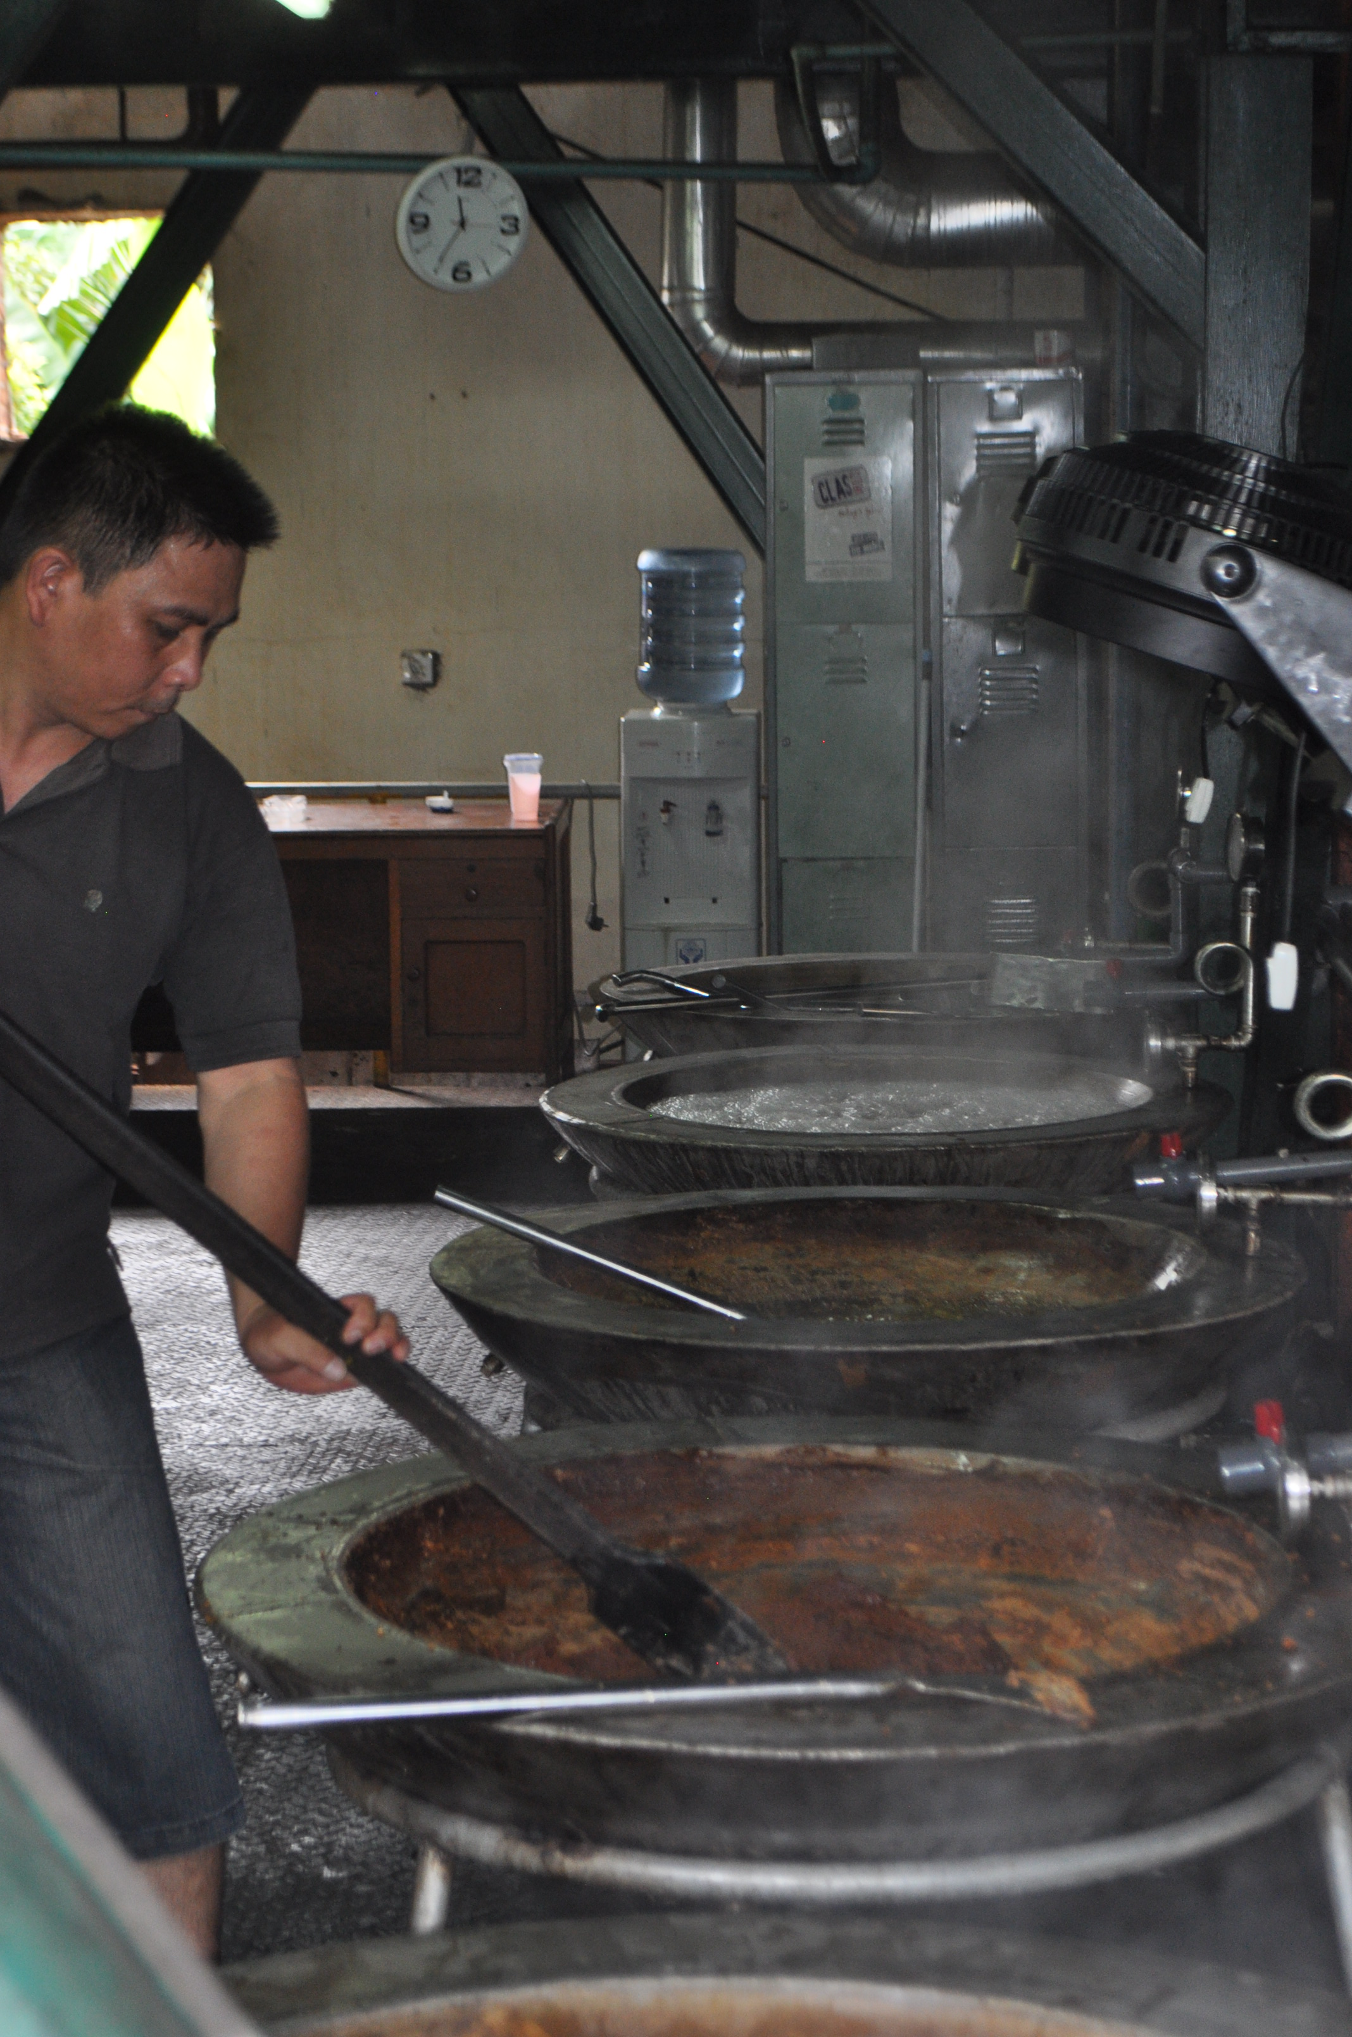
The manure from the livestock is goes into a biogas installation. Methane gas is produced which is then used as fuel for the distillation process. Wood is used as a back up.

The palm juice is placed in an evaporator and heated.
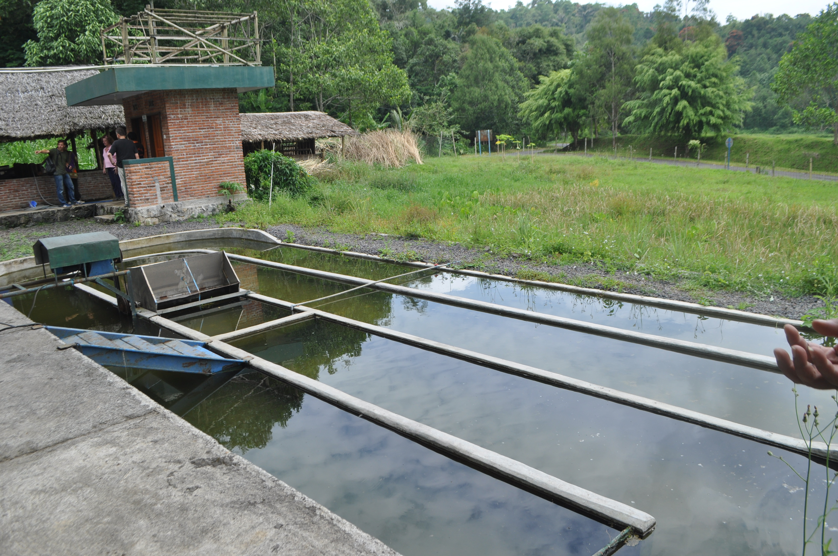

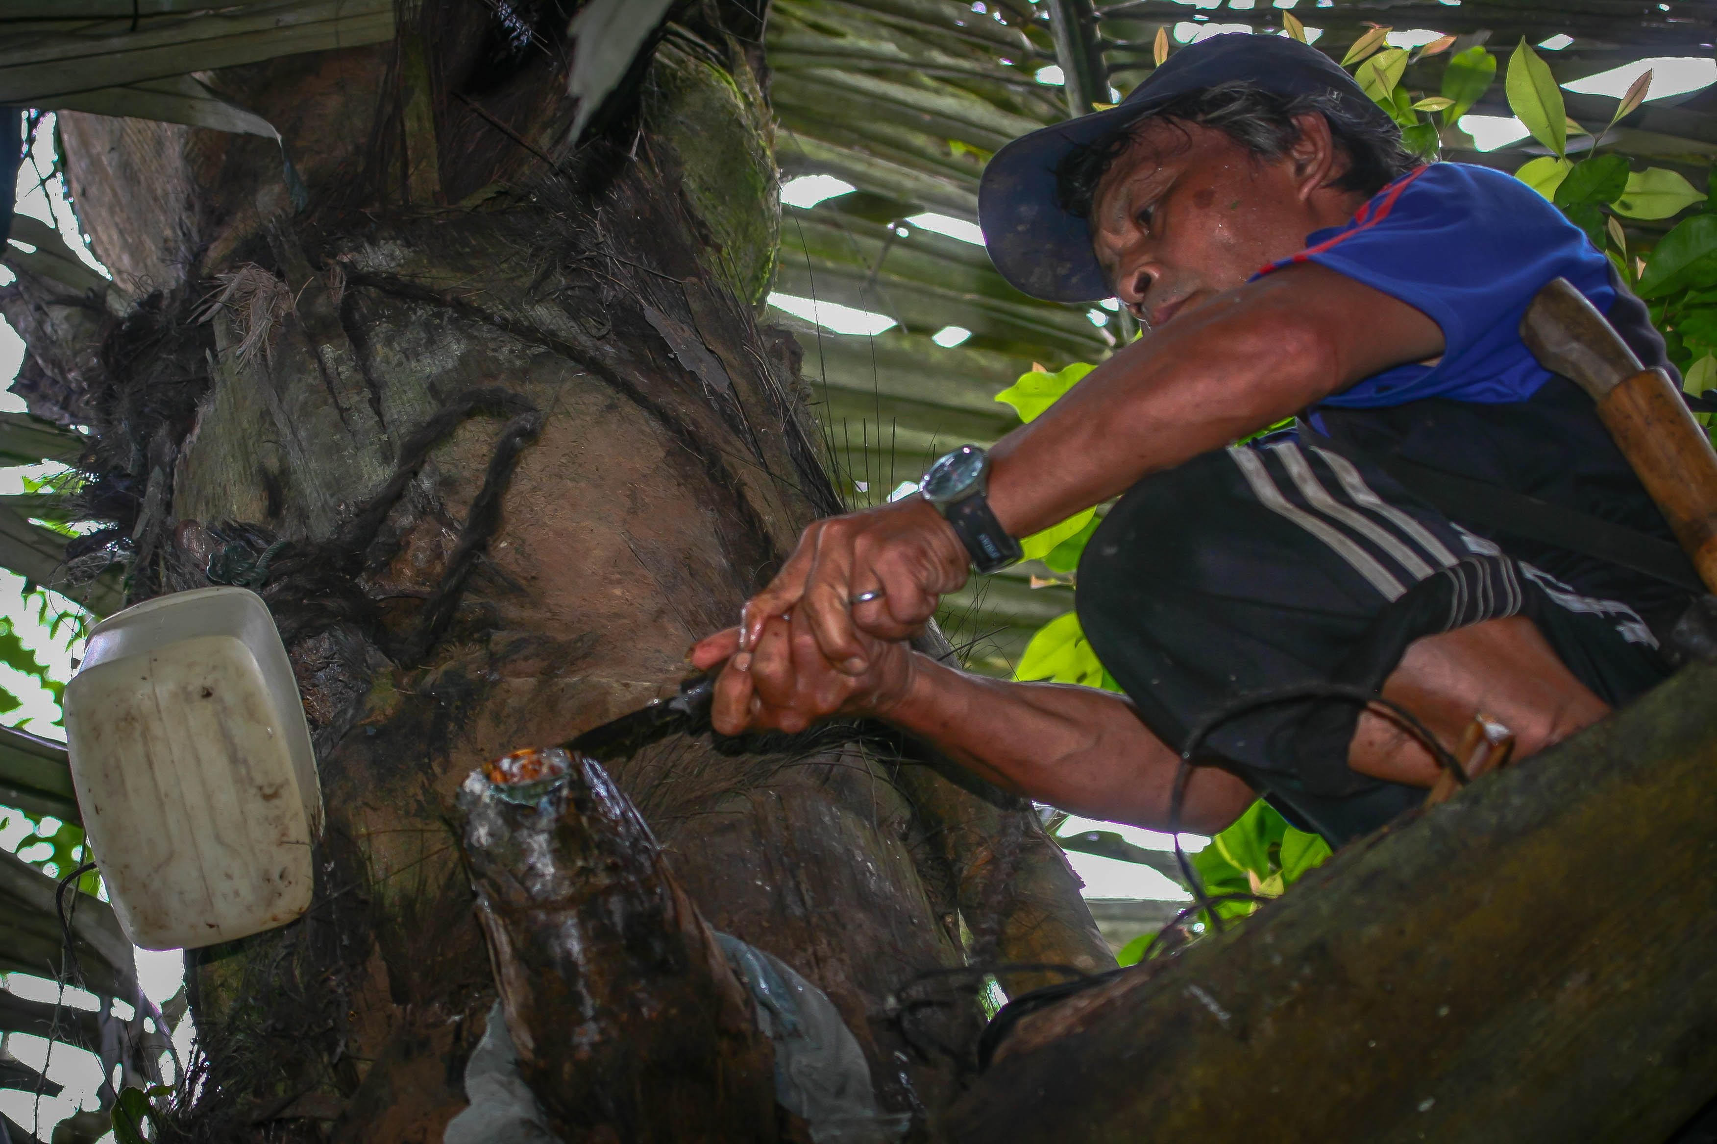
Sugar processed and exported around the world.

DISTILLER
Slurry from the livestock is used as fertilizer for the algae pond and a rice field. The rice field filters out the outflow from the Village Hub.

Village Hub.

EVAPORATOR

RICE PADDY

The manure from the livestock is placed in a bio gas installation

Every day, Yussef has to climb the sugar palm tree and tap it for juice. He climbs up the tree on a ladder made from bamboo.

BIO GAS INSTALLATION
The sugar palm juice is collected and delivered to the Village Hub

